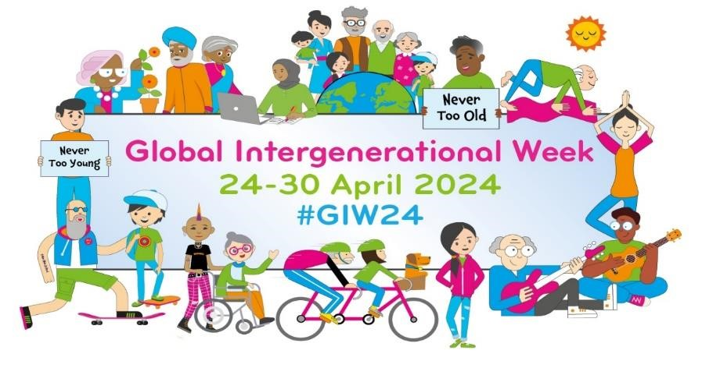

**Online Event Schedule**

|  |  |
| --- | --- |
| **Day 1 (24/04): Let’s Raise Intergenerational Awareness**  ***Virtual YMCA Dance*** - 1230 – 1300pm (aest). [Register](https://forms.office.com/pages/responsepage.aspx?id=e0clmXXDWUqP75WXPGydxtgz_kt_aPtJulxpDD0bn4hUNEQ2MzJEUlNFVk9DVEc3QTNRWTJWSEY2US4u)   * Host(s): Australia, New Zealand, Hong Kong   ***Imagine. Build. Play: Creating Spaces for All Ages*** - 1300PM – 1430PM ET. (1800 – 1930pm bst). [Register](https://zoom.us/meeting/register/tJYvfu2rrTovG9Og7SFwnvXiDBnZaQkQEVkt#/registration)   * Host(s): Canada   ***Grant-makers Symposium*** – 1600 - 1730pm (bst). [Register](https://generationsworkingtogether.org/events/-65ef0ad2cee3f)   * Host(s): Scotland & USA   ***Intergenerational Solutions to Combatting Ageism Across the Lifespan***– 11-  12pm PT/2-3 pm ET (1900pm bst). [Register](https://us02web.zoom.us/webinar/register/WN_X7_6qmYGRoq0J6Vc5oMD-w#/registration)   * Host (s): USA, WHO, HelpAge International | |
| **Day 2 (25/04): Let’s Build Intergenerational Partnerships**  ***Bringing Generations Together for Climate Action: learning from Nepal and Uganda***– 1030 – 1130am (BST) [Register](https://us06web.zoom.us/webinar/register/WN_fvFiqh6QTXGg3-R14UZMCw#/registration)     * Host(s): HelpAge International, Restless Development (Nepal & Uganda), Newcastle University.   ***Generational Misunderstandings*** - 1200 - 1330pm (bst). [Register](https://generationsworkingtogether.org/events/generational-misunderstandings-25042024) - Host(s): Scotland  ***CIPRD: The Grand Reveal!*** 1300 – 1430pm (bst). [Register](https://docs.google.com/forms/d/e/1FAIpQLSdYX6WoEjOt9JpmYdLz_IBLl1EckbZNgSLJ40oe9PlKLs_tew/viewform)   * Host(s): England | | | |
| **Day 3 (26/04): Let’s Combat Loneliness and Social Isolation**  ***Generation Marianne Seminar with one of Scandinavia’s leading architectural practices, White Arkitekter.*** *(Swedish).* [Register](https://www.anpdm.com/public/event/RegistrationForm/434750407343405B457740?utm_campaign=unspecified&utm_content=unspecified&utm_medium=email&utm_source=apsis-anp-3)- Host(s): Sweden  ***Co-creating an intergenerational climate pack: an interactive activity session*** *–* 1300 – 1430pm (bst). [Register](https://swanseauniversity.zoom.us/meeting/register/tJEscOiqpz4jE9V1eMmqQQRyzLh3VYxN0W_1#/registration)   * *Host(s): Wales*   ***InterGen Lab Webinar Series: Work & Health*** *–* 1200pm est (1800pm bst) - [Register](https://www.eventbrite.com/cc/intergen-webinar-series-3186869)   * Host(s): Challenge Factory (Canada) | | |
| **Day 4 (27/04): Let’s Celebrate Intergenerational Spaces and Communities**  ***Lives Well Lived Virtual Screening and Virtual Q&A session with filmmaker, Sky***  ***Bergman*** - 1600 – 1700pm (bst). [Register](https://generationsworkingtogether.org/events/giw24-webinar-q-a-lives-well-lived-27042024)  - Host(s): Scotland, USA | | |

**Day 5 (28/04): Let’s Break Down Age Barriers**

*No planned online events this day. Have a look at what our* [*country leads*](https://generationsworkingtogether.org/global-intergenerational-week/country-leads) *are doing locally and stay up-to-date on Social Media using #GIW24*

|  |
| --- |
| **Day 6 (29/04): EU Day – Solidarity between Generations**  ***Expert Panel Discussion with World Health Organisation and Q&A:*** ***Shifting intergenerational practice from "nice" to “essential"*** - 1430 – 1600pm (aest).  [Register](https://events.teams.microsoft.com/event/c895d6df-c3f8-4168-951b-abc942e860d3@5a7cc8ab-a4dc-4f9b-bf60-66714049ad62)   * Host(s): Australia, Singapore, New Zealand, Hong Kong, WHO.   ***Creating Intergenerational Communities (CIC):*** ***Raising the Quality of***  ***Intergenerational Practice****.* 1400 – 1530pm (bst). [Register](https://generationsworkingtogether.org/events/giw24-raising-the-quality-of-intergenerational-practice-29042024)   * Host(s): Scotland, England, Northern Ireland   ***Showcasing Local Intergenerational Projects*** – 1100 Mexico, 1300 Chile, 1400  Uruguay, 1900 Spain. Spanish[. Register](https://forms.gle/fMjHUTZxpTiyy2Ha8)   * Host(s): Mexico, Spain, Uruguay & Chile |

|  |
| --- |
| ***Eisner Prize Fellows Showcase and Info Session*** - 1300 – 1400pm (ET) (1800 – 1900pm BST). [Register](https://us06web.zoom.us/webinar/register/8317120316116/WN_A7UvvWtjTPKDYUiUvNFH6A#/registration)  - Host(s): USA |
| **Day 7 (30/04): Let's Build Intergenerational Workplaces**  ***How can generations grow together? Intergenerational Learning –*** 1000 – 1130 (cest). [Register](https://www.tickettailor.com/events/placestogrow/1220158)   * Host(s): TOY, Holis   ***The benefits of applying an intergenerational approach to the workplace* -**  1200pm - 1330pm (bst). [Register](https://generationsworkingtogether.org/events/why-change-from-a-multi-to-an-intergenerational-workforce-30042024)   * Host(s): Scotland, Singapore, USA   ***The importance of intergenerational learning: Putting knowledge into practice*** 1400 – 1530 (bst). [Register](https://generationsworkingtogether.org/events/giw24-the-importance-of-intergenerational-learning-putting-knowledge-into-practice-30042024)   * Host(s): Scotland, England, Northern Ireland | |

In addition to the events above, our Country Leads are all hosting an exciting range of in-person events across the week. Check out their [individual profiles](https://generationsworkingtogether.org/global-intergenerational-week/country-leads) to learn more.

Want to attend a particular event but are unable to? Don’t worry! All planned events will be recorded and shared online afterwards. If you have [registered to support](https://generationsworkingtogether.org/global-intergenerational-week/supporter-registration) the campaign, links will be sent to you directly.

Finally, if you are hosting an event during Global Intergenerational Week 2024, please register it with us. This allows us to monitor everything that is going on and gives us a better picture of the impact of the campaign.

Any questions, please contact: ruairidh@gwt.scot